Chapter 16, Solution 23.

Obtain v(t) for t > 0 in the circuit of Fig. 16.46.

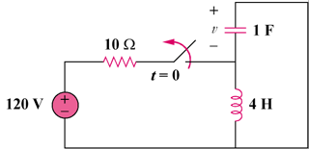
90 V

Figure 16.46
For Prob. 16.23.

Solution

Step 1. First we need to calculate the initial conditions. Clearly since the inductor looks like a short, v(0) = 0 and i_{L}(0) = 90/10 = 9 amps. Next we convert the circuit into the s-domain and solve for V and then obtain the partial fraction expansion and convert back into the time domain.

4s

9/s

1/s

+

V

−

[(V–0)/(1/s)]+(–9/s)+[(V–0)/4s] = 0

Step 2.
[s+(1/(4s))]V = 9/s = [(s²+0.25)/(4s)]V or V = 36/[(s+j0.5)(s–j0.5)]
= [A/(s+j0.5)] + [B/(s–j0.5)] where A = 36/(–j) = 36∠90˚ and
B = 36/(j) = 36∠–90˚. Thus,
v(t) = 36[e^{–(j0.5t–90˚)}+e^{(j0.5t–90˚)}]u(t)

= 18cos(0.5t–90˚)u(t) volts.

